**EXPERIMENT -2**

**AIM:-Give overview of different UML tools available. Introduce Star UML. And study about entitiesrelationship diagrams.**

**DIFFERENT UML TOOLS**

### 1) StarUML:

StarUML is an open source software modeling tool. It provides eleven types of diagram. StartUML 2 is compatible with UML 2.x versions.

**Features:**

* Allows you to create Obje3ct, Use case, Deployment, Seque3nce, Communication, Activity, and profile Diagram.
* Allows you to discover and install third-party extensions.
* Work with same UX in multiple platforms including macOS, Windows, and Linux.
* No limit for using this commercial software for evaluation.

### 2) Creately:

Creately is a dynamic diagramming tool that can be deployed from the cloud or on the desktop and as a plugin for JIRA and Confluence. It is designed by its parent company, Cinergix, to be a simple platform that robustly supports collaborations between team members.

**Features:**

* One-Click Create,Drag-and-Drop Function
* PresetConnectors,Alignment, Sizing, Grouping
* Themes &ColorPalette,SmartShapes,Text to Shape
* Smart Connectors,Real-Time Collaboration
* Inline Comments & Discussion Threads
* Full Revision History
* Sharing Links &Emails,Private Embedding & Publication of Diagrams
* Visio Importing,PDF Export with Links
* SVG Import &Export,Templates& Examples
* Offline Work &Synchronization,Real-Time Collaboration

### [LucidChart](https://bit.ly/39C6v3Q):

Lucidchart is an intuitive web-based diagramming tool that allows you to creatediagrams quickly and easily. Lucidchart is a cloud-based diagram creation softwarethat allows users to create flowcharts and other diagrams.

**Features:**

## Easily style shapes and Work faster with keyboard shortcuts

## Organize your diagrams with containers

## Include links and layers for easy-to-read diagrams

## Present your diagram

### 4) UML designer tool:

UML Designer tool offers a set of common diagrams to work with UML 2.5 models. The tool provides an easy method for the transition from UML to domain-specific modeling.

**Features:**

* Allows user to re-use provided representations and work in total transparency on both DSL and UML models
* Helps you to create a Class diagram, Component Diagram, and composite structure Diagram
* Allows you to use legacy UML models and start working with DSL.

### 5) Smartdraw

SmartDraw offers a full suite of diagrams, templates, tools and symbols to design anything. Use SmartDraw to make flowcharts, residential and commercial floor plans, organizational charts, CAD and engineering diagrams, electrical designs, landscape designs, network diagrams, app and site mockups, wireframes, and more.

**Features:**

* Add photos and images.
* Add, delete or move shapes with auto adjusting.
* Automatic formatting.
* Available in 100 languages.
* Chart-based diagrams.
* **Collaboration** tools.
* Create and edit diagrams online.
* Design themes.

Introduction Of StarUML:

Symbol of starUML:-



StarUML is a sophisticated software modeler aimed to support *agile* and *concise*modeling. StarUML is a [UML tool](https://en.wikipedia.org/wiki/UML_tool) by MKLab.

The main targets of users are:

Agile and small development teams.

Professional persons

Educational institutes.

**The key features of StarUML are:**

Multi-platform support (MacOS, Windows and Linux)

UML 2.x standard compliant

Entity-Relationship diagram (ERD)

Data-flow diagram (DFD)

Flowchart diagram

Multiple windows

Modern UX

Dark and light themes

Retina (High-DPI) display support

Model-driven development

Open APIs

Various third-party extensions

Asynchronous model validation

Export to HTML docs

Automatic updates.

**ENTITY RELATIONSHIP DAIGRAM:**

**Overview**

An Entity–relationship model (ER model) describes the structure of a database with the

help of a diagram, which is known as Entity Relationship Diagram (ER Diagram). An ER

model is a design or blueprint of a database that can later be implemented as a

database. The main components of E-R model are: entity set and relationship set.

SHAPES TO REPRESENT ER – DIAGRAMS

* RECTANGLE : represents entity set
* ELLIPSES: Attributes
* DIAMONDS: Relationship Set
* LINES: They link attributes to Entity Sets and Entity sets to Relationship Set
* DOUBLE ELLIPSES: Multivalued Attributes
* DASHED ELLIPSES: Derived Attributes
* DOUBLE RECTANGLES: Weak Entity Sets
* DOUBLE LINES: Total participation of an entity in a relationship set

**Components of ER Diagram**

a) ENTITY

A real-world thing either living or non-living that is easily recognizable andnonrecognizable. It may be a physical thing or simply a fact about the enterprise oran event that happens in the real world.

An entity can be place, person, object, event or a concept, which stores data in thedatabase.

Examples of entities:

* Person: Employee, Student, Patient
* Place: Store, Building
* Object: Machine, product, and Car
* Event: Sale, Registration, Renewal
* Concept: Account, Course
* **Weak Entity:**

An entity that cannot be uniquely identified by its own attributes andrelies on the relationship with other entity is called weak entity. The weakentity is represented by a double rectangle.

For example – a bank accountcannot be uniquely identified without knowing the bank to which theaccount belongs, so bank account is a weak entity.

b) ATTRIBUTE

An attribute describes the property of an entity. An attribute is represented asOval in an ER diagram.

There are four types of attributes:

* Key attribute
* Composite attribute
* Multivalued attribute
* Derived attribute

c) RELATIONSHIP

A relationship is represented by diamond shape in ER diagram, it shows the

relationship among entities. There are four types of relationships:

1.One to One:-When a single instance of an entity is associated with a single instance of anotherentity then it is called one to one relationship. For example, a person has onlyone passport and a passport is given to one person.

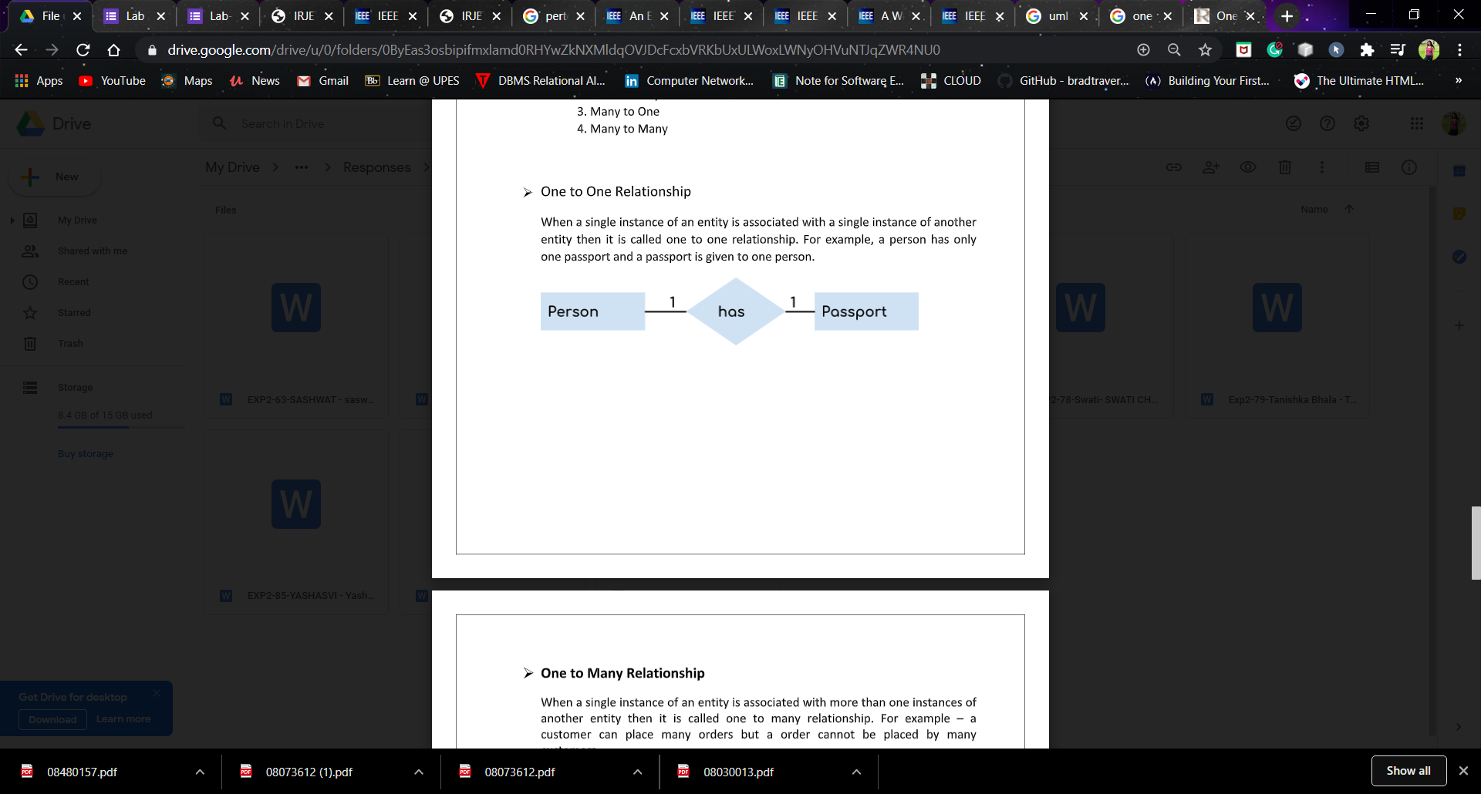

2. One to Many:-When a single instance of an entity is associated with more than one instances ofanother entity then it is called one to many relationship. For example – acustomer can place many orders but a order cannot be placed by manycustomers.

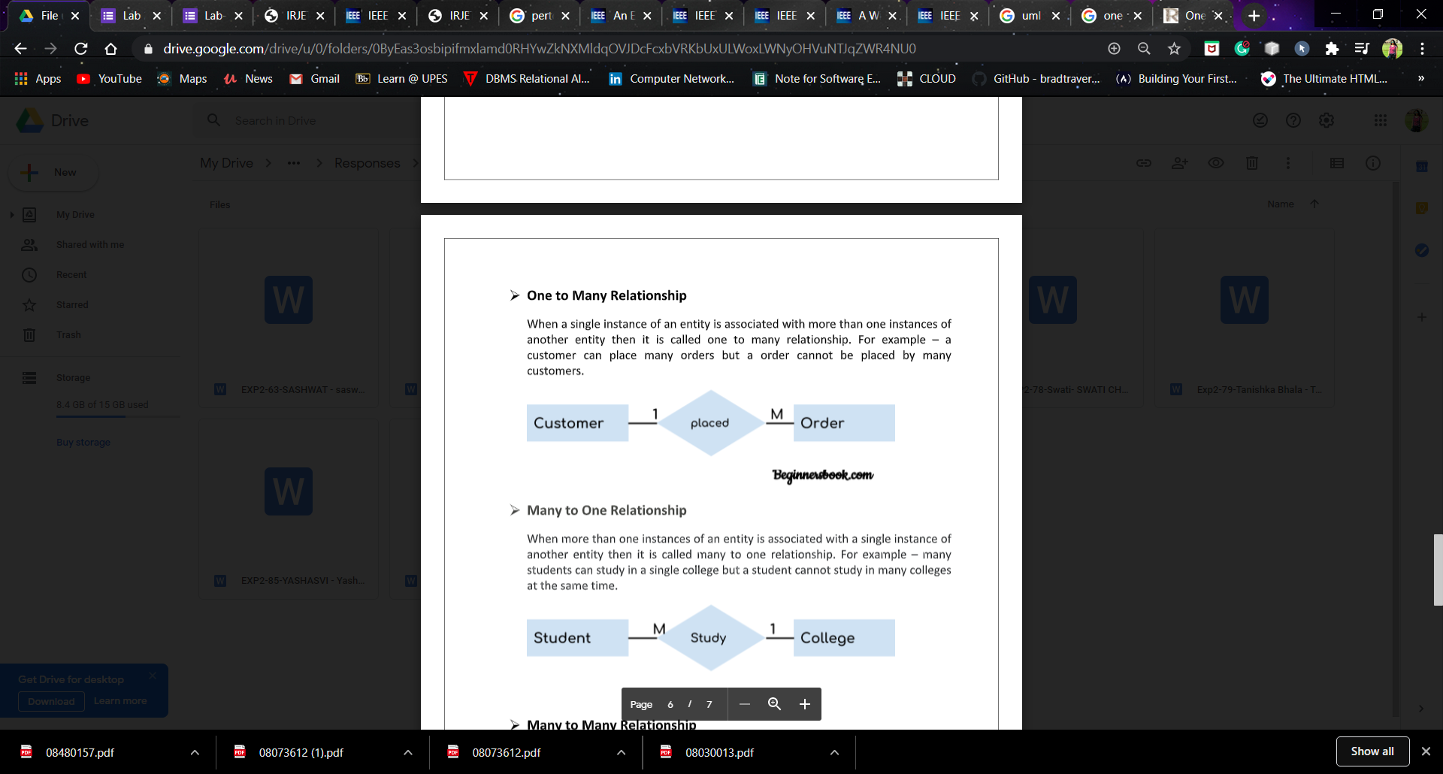

3. Many to One:-When more than one instances of an entity is associated with a single instance ofanother entity then it is called many to one relationship. For example – manystudents can study in a single college but a student cannot study in many collegesat the same time.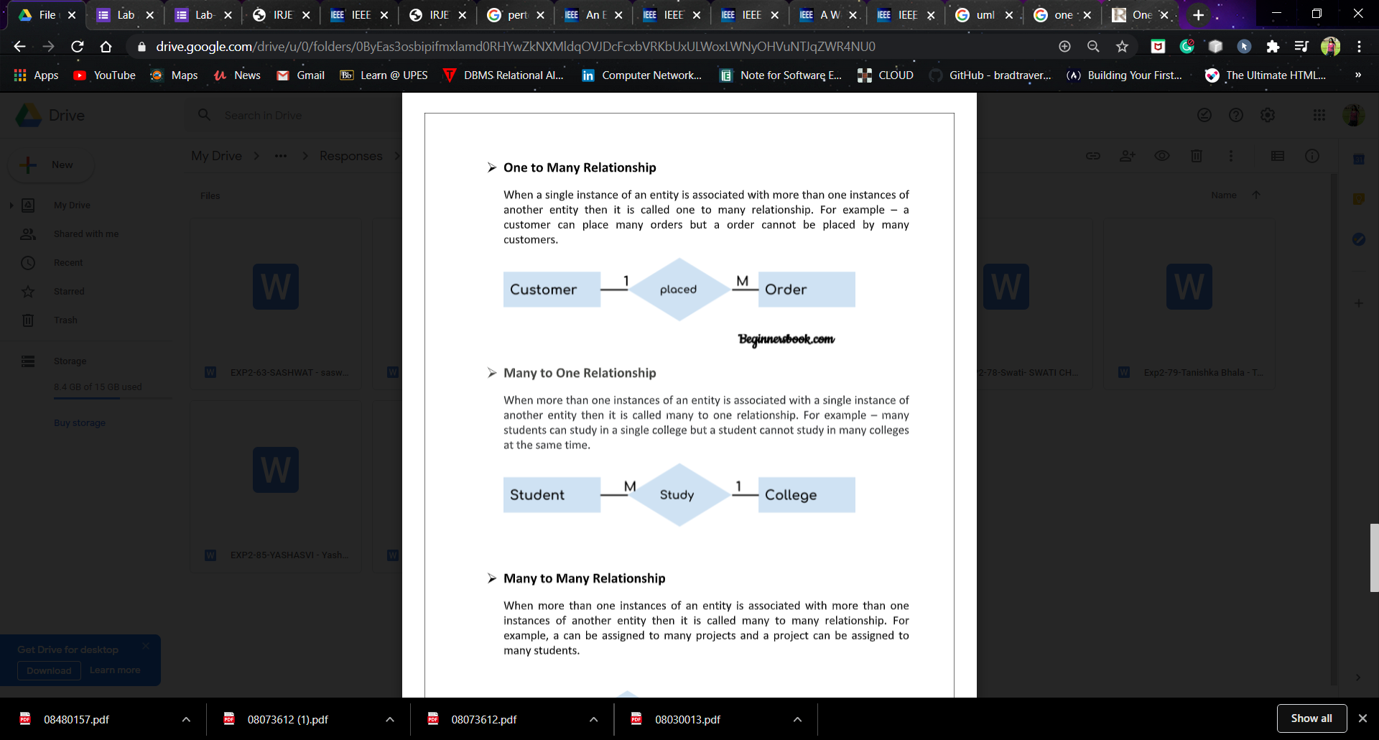4. Many to Many:- When more than one instances of an entity is associated with more than oneinstances of another entity then it is called many to many relationship. Forexample, a can be assigned to many projects and a project can be assigned tomany students.

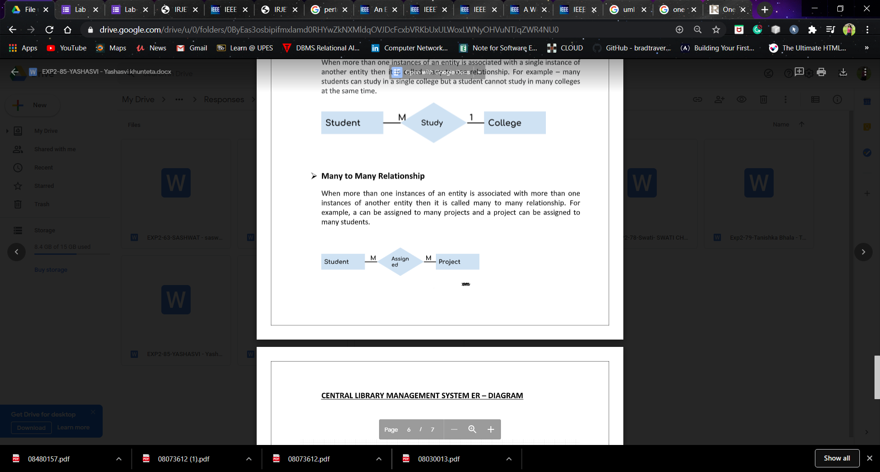

**CENTRAL LIBRARY MANAGEMENT SYSTEM ER – DIAGRAM**

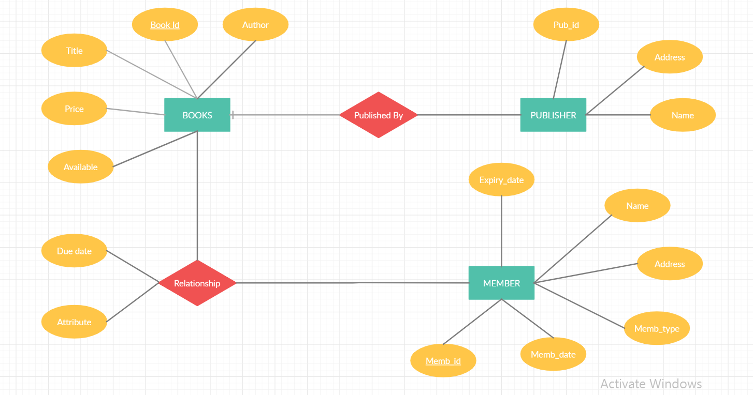

**NAME-AKHILESH TOMAR**

**ROLL NO.-08**

**B.TECH CSE(IOT)**

**BATCH-B1**